**DON BOSCO HIGHER SECONDARY SCHOOL, TURA**

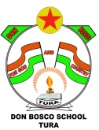

Lower Chandmari

Tura, West Garo Hills,

Meghalaya – 794002

Mobile: ***6000765641***

E-mail: [dbschooltura@gmail.com](mailto:dbschooltura@gmail.com)

Website: [www.dbhsstura.in](http://www.dbhsstura.in)

Dated 27th June, 2025

NOTICE

**Dear Students/Parents & Teachers,**

This is to inform you that our **school will break for Summer Vacation from 30th June to 13th July 2025. The school will re-open on 14th July, 2025 (Monday). Attendance on the re-opening day is a must (compulsory). The students absenting on the re-opening day without valid reason/s will invite fine of Rs. 300/- only.**

**Thank you for your understanding and co-operation.**

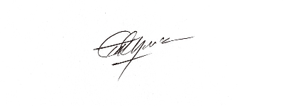***Wishing you all Happy Holidays!***

Principal